Forskolin Could Protect Against Flutamide-Induced Osteoporosis Modulation of Serum Osteocalcin and Sclerostin in Rats
Abstract:
Background: Osteoporosis (OP) is a disease characterized by decreased bone mass and is widely recognized as a major health problem. Flutamide is an androgen receptor blocker used in treatment of cancer prostate. Its prolonged use is usually associated with OP which is now treated by bisphosphonates. Aim: this work was designed to explore the potential benefit of forskolin (a cAMP/protein kinase A pathway stimulant) alone and in combination with alendronate on flutamide -induced osteoporosis in rats.
Subjects and methods: Forskolin 6 mg/kg/day orally was taken either singly or in combination with Alendronate 0.1mg/kg /day orally in rat model with osteoporosis which was induced by flutamide 15 mg/kg/day orally for 4 weeks (in a three-months case-controlled study, at clinical pharmacology department labs- Benha Faculty of Medicine- Benha University). The tested parameters include bone formation marker serum osteocalcin (OC), bone resorption markers as urinary hydroxyproline (HPO) and serum sclerostin (SOST) as well as bone histopathological and histomorphometric studies on femoral bone. Results: Flutamide produced full picture of OP manifested as significant rise in urinary HPO and serum SOST level with significant decreased in serum OC level as well as distortion of microscopic bone architecture with rarefaction of cortex and trabeculae of tested bone. Alendronate failed to induce significant improvement in histomorphometric parameters or bone formation marker. It only resulted in significant decrease of urinary HPO excretion. Forskolin significantly decreased urinary HPO excretion and serum SOST with significant increase in serum OC level. It produced marked improvement in both histopathologic and histomorphometric parameters. Moreover, Forskolin augmented the effect of alendronate. Conclusion: Forskolin is a promising agent in management of OP either singly or in combination with alendronate.
Keywords: Flutamide, Forskolin, Osteoporosis.
Introduction
Cancer Prostate is the most commonly diagnosed cancer and the second leading cause of death in men, with incidence approximately 1.6 million /year ^{[1]}.The 5-year survival rate in the United States is 99% ^{[2]}. Its treatment options include surgery, radiation, and medical therapy either chemotherapy or androgen deprivation therapy before radiation to reduce tumor size. Androgen deprivation therapy aims at lowering androgen levels or stopping them from getting into cancer prostate cells leading to shrinkage or grow more slowly for a time ^{[2]}.
Androgen deprivation therapy include androgen synthesis inhibitors e.g. abiraterone and androgen receptor blocker such as flutamide ^{[3]}. Androgen deprivation therapy deprives bone from the anabolic effect of androgen ^{[4]}. In addition, cancer prostate and osteoporosis commonly coexist in men over 65 years as a result of age-related decline in androgen levels (andropause)^{[5]}. Osteoporosis (OP) is a bone metabolic disease characterized by low bone mineral density with high risk for fractures. It occurs when there is an imbalance between bone resorption and bone formation during the bone remodeling process ^{[6]}. Osteoporosis is generally viewed as resulting from a combination of age-related, hormonal, dietary, lifestyle, and genetic factors, all of which can lead to reduced bone mass ^{[7]}.
Bisphosphonates (BPs) are known drugs that inhibits the loss of bone mass ^{[8]}. Many BPs have been approved and utilized to manage osteoporosis, e.g., alendronate, risedronate, zoledronate ^{[9]}. Moreover, they produce some troubles and side effects as marked gastrointestinal upset, increased incidence of cancer esophagus and atrial fibrillation ^{[10]}. In addition, over suppression of bone turnover may result in increased incidence of subtrochanteric shaft fracture of hip bones ^{[11]}.
Forskolin, a plant product produced by Coleus plant of mint family, is an adenyl cyclase stimulant that control metabolic pathways related to vascular reactivity, platelet aggregation and cell survival through activation of protein kinase A and cAMP regulated guanine nucleotide exchange factor-1^{[12]}.It is also involved in expression of pro-osteogenic cytokines like interleukin 11, insulin like growth factor 1 and transforming growth factor- B^{[13]}.Thus, it is plausible tool for increasing bone formation –a target not achieved by any other drug used in this respect except intermittent recombinant parathyroid hormone fragment ^{[14]}.
In this work, the possible beneficial effect of forskolin administration was investigated either singly or in combination with alendronate (bisphosphonate derivative) in a rat model of osteoporosis induced by flutamide. This is to simulate the actual clinical situation in osteoporosis as a side effect of androgen deprivation therapy. The efficacy of the tested drug was estimated in combination with alendronate which is one of the essential drugs used in standard medical protocol of cancer prostate to prevent osteoporotic side effect as a result of bone metastasis or androgen deprivation therapy.
Materials and methods
Animals
Forty adult male albino rats weighing between 190-220 g obtained from Experimental Animal Breeding Farm, (Helwan-Cairo) were used in this study. All rats were kept 7 days for adaptation before the experiment and housed in metabolic cages at room temp. 25Cº± 2 and 12 hours dark/ light cycle with free access to water and balance diet ad libitum. The study was carried out following direction of Ethics Committee at Benha University approval number: 00086.
Drugs and chemicals
Forskolin, Flutamide and Alendronate were purchased from Sigma-Aldrich Chemical Company (St. Louis, Mo., USA). The biochemical analysis was performed using standard kits. The chemicals used in histopathological study were all high analytical grade.
Experimental protocol:
Rats were randomly allocated into 5 groups, each of 8 rats. Group I (Control): In which rats received only saline by oral gavage in comparable volumes of tested drug dosage. Group II: Flutamide-induced osteoporotic group (Flut-OP group) in which rats administered Flutamide (15 mg/kg/day orally) for four weeks ^{[15]}. Rate in group III (forskolin-treated flutamide–induced osteoporotic group) received forskolin at dose of 6 mg/kg per day orally ^{[16]} simultaneously with flutamide (15 mg/kg/day orally) for four weeks. Group IV (Alendronate-treated flutamide induced osteoporotic group) in which rats received alendronate at a dose of 0.1 mg/kg/day orally ^{[17]} simultaneously with flutamide (15 mg/kg/day orally) for four weeks. In group V (Forskolin + alendronate-treated flutamide -induced osteoporotic group of rats) rats received forskolin in the same manner as group III in combination with alendronate as in group IV.
Samples collection and preparation:
Twenty-four hours before the end of experiment, each rat was kept in special metabolic cage with perforated platform to collect urine then centrifuged and the supernatant kept at-20ºC to be analyzed for hydroxyproline (HPO) ^{[18]}. At the end of experiment, all rats were anesthetized with intraperitoneal injection of pentobarbital sodium in a dose of 9.1mg/kg ^{[19]}. Blood samples were collected from retroorbital plexus, incubated for 1 hour at 37 ºC then centrifuged for 20 minutes at 5000 rpm in cold centrifuge. Serum samples were kept at -20 ºC till analyzed. Then, all animals were killed by cervical dislocation. The femur was excised, cleared of fat and connective tissue and immediately fixed in 10% formaldehyde for 48h then preserved in 10% ethylene diamine tetra acetic acid (EDTA) for histopathological investigation. Each specimen was processed to get 6mm thick paraffin sections to be stained with hematoxylin and eosin (H&E) stain ^{[20]}.
Urinary hydroxyproline(HPO): Was determined in urine according to the modified method of Prockop et al. ^{[21]}.
Serum sclerostin (SOST): Was measured using a Solid Phase Sandwich ELISA (Mouse/Rat SOST kit, R&D Systems Europe, Ltd., Abingdon, UK) according to the manufacturer’s protocol.
Serum osteocalcin (OC): Was evaluated by using rat OC (Rost-ELISA) kit from biosource-Belgium, according to manufacturer’s protocol.
Trabecular and cortical bone thickness: Were investigated after staining with hematoxylin and eosin (H&E) stain ^{[20]}. Trabecular bone thickness was measured by drawing multiple perpendicular lines through the whole width of each trabecula (Fig1B). Cortical bone thickness was measured by drawing multiple perpendicular lines from periosteum to the endosteum (Fig. 1c).
Statistical analysis
Results are presented as mean ± standard deviation (mean ± SD). Statistical analysis was performed using One-way Analysis of Variance (ANOVA) followed by Tukey Kramer post-test at P< 0.05.
Results
In this work flutamide administration for four weeks resulted in significant increase in urine HPO and serum SOST associated with significant reduction in serum OC (Table,1) as well as significant decrease in cortical and trabecular bone thickness with widening of bone marrow spaces (Table 2, Fig. 2D) compared to normal control group. Concomitant administration of forskolin with flutamide resulted in significant improvement of all previously mentioned parameters compared to flutamide osteoporotic group while alendronate was significantly better than forskolin as regard to urinary HPO reduction. Combination of forskolin and alendronate had more powerful improving effect than either drug singly. Histopathological examination revealed that flutamide administration resulted in disruption of the classical structure of compact bone as well as cancellous bone (Fig.2A & Fig.2C respectively) in the form of irregular thinned compact bone with irregular outer and inner surfaces covered by thickened periosteum and endosteum with decreased osteocytes. Both forskolin and alendronate produced obvious improvement of the previously mentioned histological picture (Fig. 3 A, B & Fig. 4 A, B) but the best results were obtained on drug combination (Fig. 5 A, B) compared with either drug alone.

Table 1: Effect of forskolin (6 mg /kg /day orally for 4 weeks) and/ or alendronate (0.1 mg /kg/day oral for 4 weeks) administration on urinary HPO (µg/ml), serum OC (ng/ml) and serum SOST (pg/ml) on flutamide (15 mg /kg/day oral for 4 weeks)- induced OP in adult male rats.

Groups | Urinary HPO  (µg/ml) | Serum SOST  (pg/ml) | Serum OC  (ng/ml)
Group(I): Control | 0.011 ± 0.002 | 205 ± 25.2 | 4.1523 ± 0.5
Group II : Flut-OP | 0.215 ± 0.015ª | 725 ± 112.5ª | 1.412 ± 0.03 ª
Group III: FORS-Flut-OP | 0.065±0.005^{a,b} | 315 ± 32.4^{a,b} | 2.7741 ± 0.605^{a,b}
Group IV: ALEN-Flut-OP | 0.051 ± 0.018 ^{a,b,c} | 687 ± 59.7^{a,c} | 1.58 ± 0.53^{a,c}
Group V: FORS + ALEN -Flut-OP | 0.039 ± 0.001^{a,b,c,d} | 349. ± 45.6^{a,b,d} | 3.12 ± 0.98^{a,b,d}
Data represented by mean ± SD a: Significant difference compared with control group, b: Significant difference compared with Flu-OP group, c: Significant difference compared with FORS-Flu-OP group and d: Significant difference compared with ALEN-Flut-OP group. The mean difference is significant < 0.05 levels
Table 2: Effect of forskolin (6 mg /kg /day orally for 4 weeks) and or alendronate (0.1 mg /kg/day oral for 4 weeks) administration on average (Mean ± SD) trabecular and cortical bone thickness on flutamide (15 mg /kg/day oral for 4 weeks) induced OP in femur of adult male rats (n=8).
Groups | Trabecular-bone thickness (µm) | Cortical bone thickness (µm)
Group(I): Control | 81.87 ± 11.52 | 295.91 ± 38.55
Group II : Flut-OP | 42.58 ± 8.49ª | 221.37 ± 40.12ª
Group III: FORS-Flut-OP | 157.77 ± 17.61^{a,b} | 423.57 ± 75.19^{a,b}
Group IV: ALEN-Flut-OP | 51.99 ± 10.71^{a,c} | 238.58 ± 31.59^{a,c}
Group V: FORS + ALEN -Flut-OP | 168.79 ± 24.16 ^{a,b,d} | 453.91±88.8^{a,b,d}
Data represented by mean ± SD a: Significant difference compared with control group, b: Significant difference compared with Flu-OP group, c: Significant difference compared with FORS-Flu-OP group and d: Significant difference compared with ALEN-Flut-OP group. The mean difference is significant < 0.05 levels

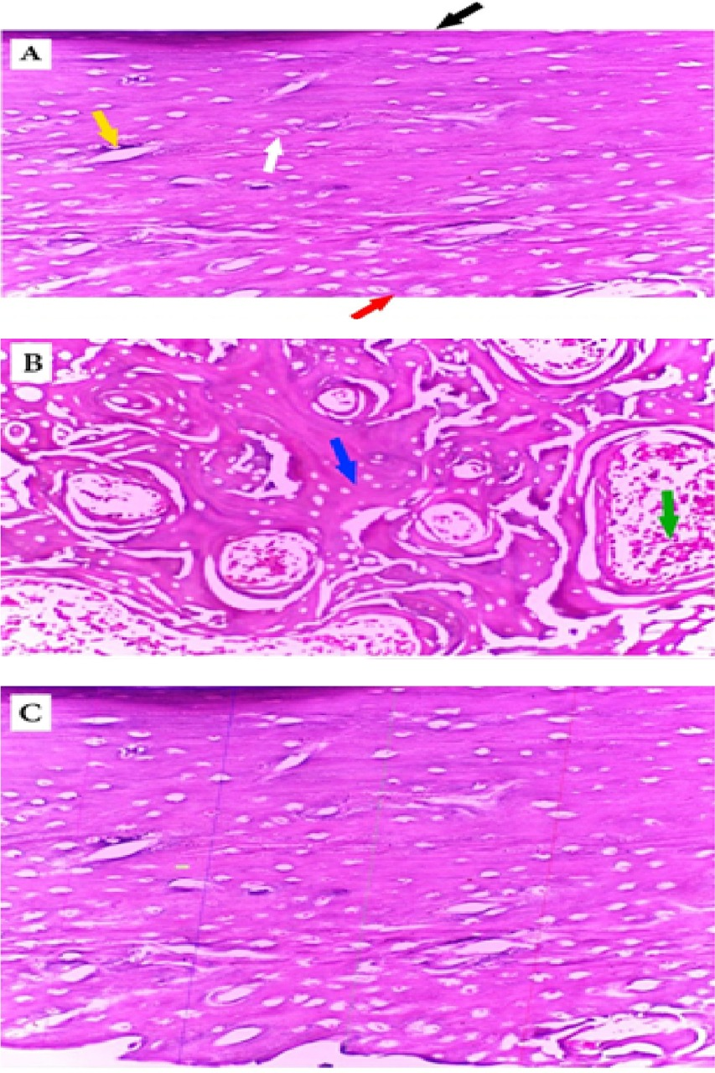
Fig. (1): (A) Longitudinal sections of the middle shaft of femur of normal control rat shows an outer fibrous layer, periosteum, an inner layer facing the marrow cavity, endosteum, normal cortical width of the shaft, normal osteocytes and Haversian canals. (B) The head of the femur of same group showing normal architecture of the trabeculae of the inner cancellous bone and bone marrow spaces. (A and B) Hematoxylin and eosin-stained section×200.(C) morphometric measurement ×400.
Black arrow : periosteum White arrow : :: osteocyte
Red arrow : endosteum blue arrow : trabecular bone thickness
Yellow arrow : Haversian canal green arrow : bone marrow cavity

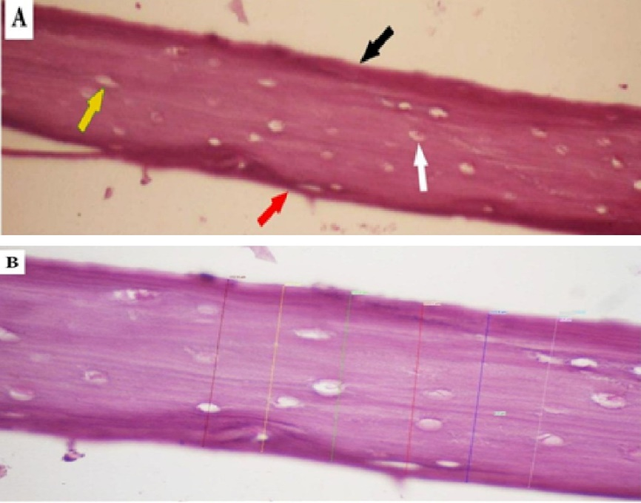
Fig. (2): (A) Longitudinal sections of the middle shaft of group II showing deformation of the general architecture of the tissue, thickened periosteum, thickened endosteum, marked decrease in cortical width of the shaft, marked decrease in osteocytes and widened Haversian canals. (A) Hematoxylin and eosin-stained section; ×200. (B) morphometric measurement; ×400.
Black arrow : periosteum White arrow : :: osteocyte
Red arrow : endosteum blue arrow : trabecular bone thickness
Yellow arrow : Haversian canal green arrow : bone marrow cavity

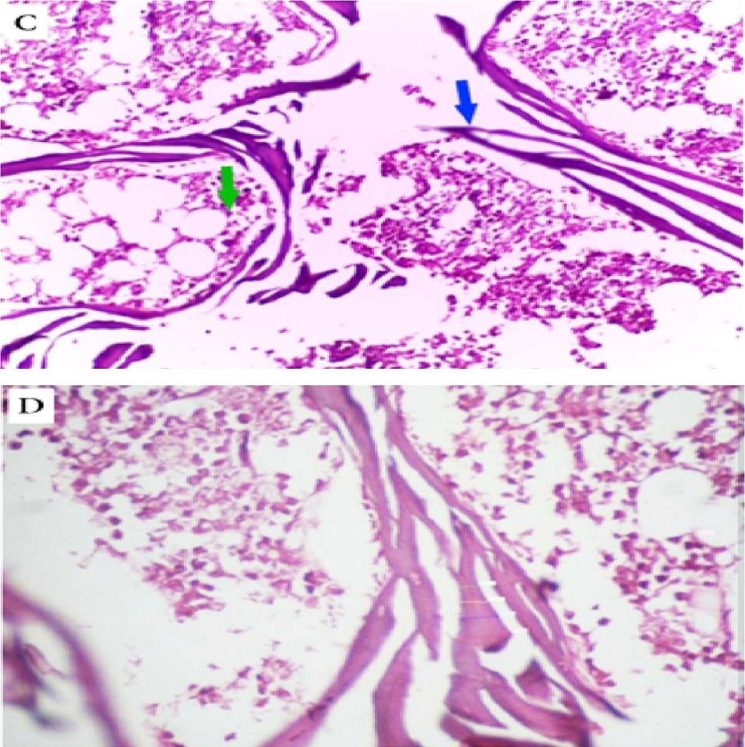

Fig. (2): (C) A photomicrograph of a section of trabecular bone of group II showing marked reduction in trabecular thickness and widening of bone marrow spaces. (C) Hematoxylin and eosin-stained section, ×200. (D) morphometric measurement, ×400.
Black arrow : periosteum White arrow : osteocyte
Red arrow : endosteum blue arrow : trabecular bone thickness
Yellow arrow : Haversian canal green arrow : bone marrow cavity

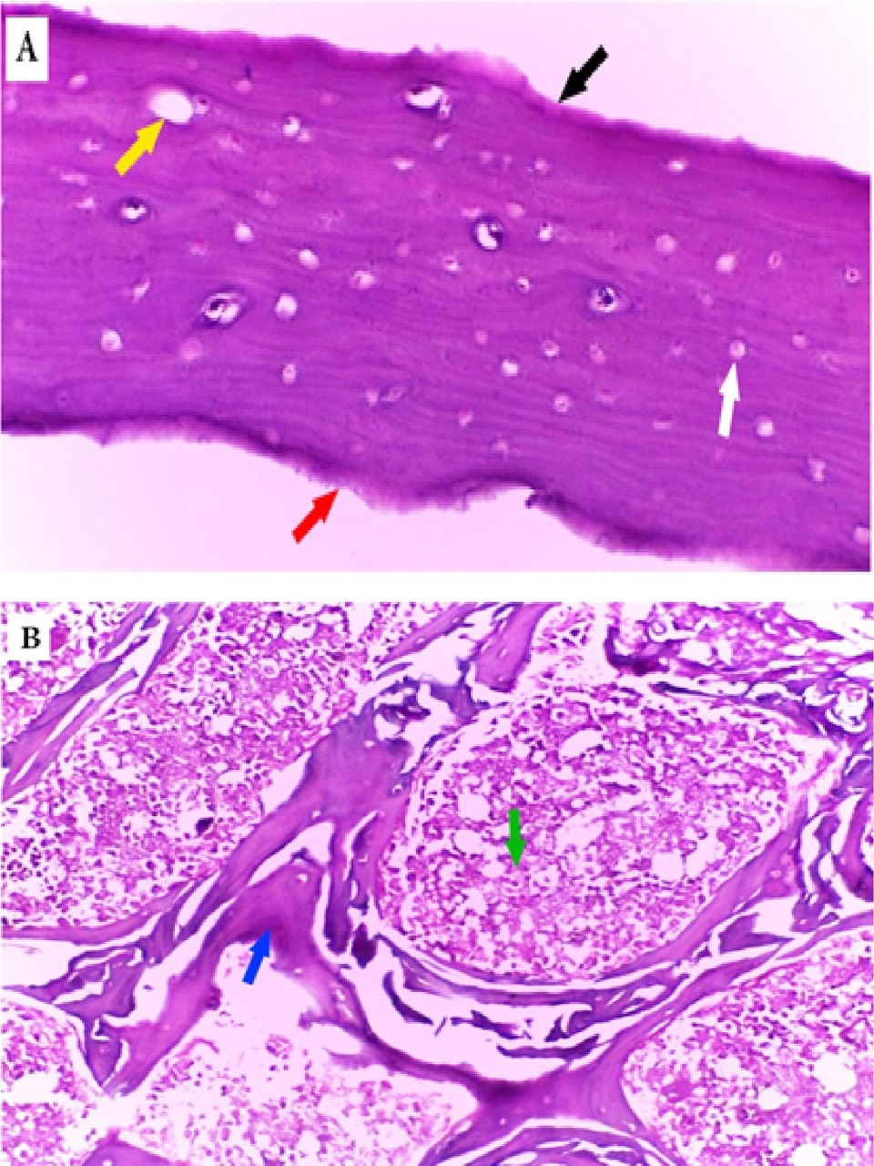

Fig. (3): (A) A longitudinal section of the middle shaft of the femur of group III rats showing marked increase in cortical bone thickness with increased osteocytes. (B) A section of trabecular bone of same group showing marked increase in trabecular area and widening of bone marrow spaces (A-B) Hematoxylin and eosins tained section, ×200.
Black arrow : periosteum White arrow : osteocyte
Red arrow : endosteum blue arrow : trabecular bone thickness
Yellow arrow : Haversian canal green arrow : bone marrow cavity

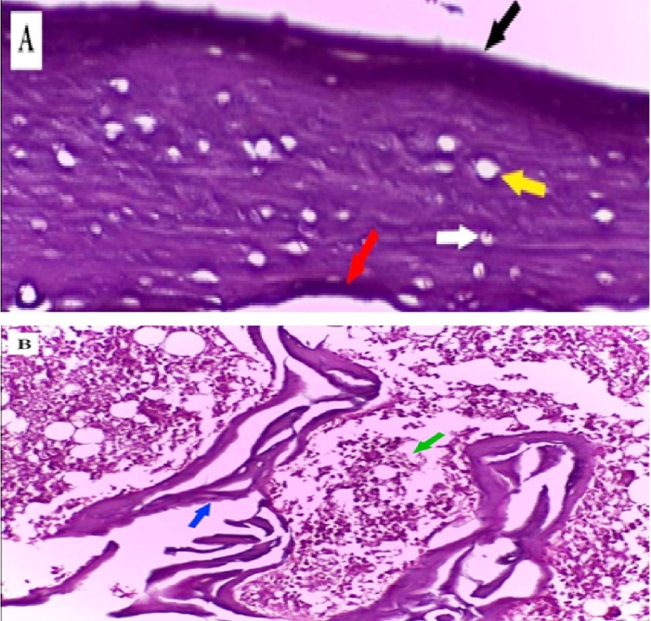

Fig. (4): (A)Longitudinal sections of the middle shaft of group IV rats showing thickened periosteum, thickened endosteum, marked decrease in cortical width of the shaft, marked decrease in osteocytes and widened Haversian canals. (B) A photomicrograph of a section of trabecular bone of group IV rats showing marked reduction in trabecular thickness and widening of bone marrow spaces. (A-B) Hematoxylin and eosin-stained section, ×200.
Black arrow : periosteum White arrow : osteocyte
Red arrow : endosteum blue arrow : trabecular bone thickness
Yellow arrow : Haversian canal green arrow : bone marrow cavity

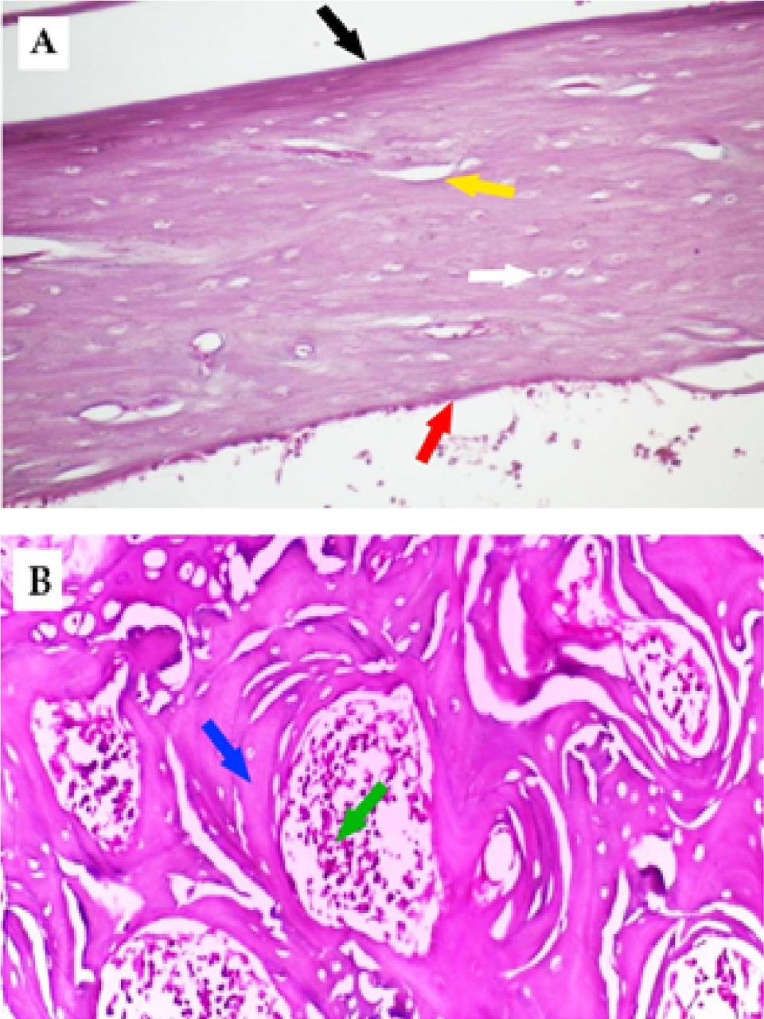

Fig. (5): (A) A longitudinal section of the middle shaft of the femur of group V rat showing marked improvement of the cortical bone thickness, osteocytes and Haversian canals. (B) A section of trabecular bone of the same group shows marked improvement of trabecular thickness and bone marrow cavities. (A-B) hematoxylin and eosin-stained section; ×200.
Black arrow : periosteum White arrow : osteocyte
Red arrow : endosteum blue arrow : trabecular bone thickness
Yellow arrow : Haversian canal green arrow : bone marrow cavity

Discussion
The present study aimed to investigate the potential protective effect of forskolin against flutamide- induced osteoporosis. The results of this work revealed that oral administration of flutamide for 4 weeks in male adult albino rats disturbed bone formation in the form of marked decrease in serum concentration of osteocalcin, a reliable marker of bone formation, and increase in sclerostin as well as urinary hydroxyproline excretion, markers of bone resorption ^{[22]}. Osteocalcin is a hydroxyapatite-binding, protein exclusively synthesized by osteoblast and hypertrophic chondrocytes. It is involved in the process of osteoid mineralization, as the protein is expressed mainly during this phase of bone formation. It has multiple vitamin K dependent gamma carboxy glutamate residues which binds calcium. Although a smaller fraction (15%) is released into the circulation where it can be detected by immunoassays, serum levels of immunoreactive OC have been shown to correlate well with the bone formation rate as assessed by histomorphometry ^{[23]}.
In the present study, the increase in serum sclerostin level in flutamide induced- osteoporotic animal group may indicate an arrested bone formation because this protein is a morphogenic protein inhibitor. It antagonizes the effect of bone morphogenic proteins ^{[24]} or inhibiting Wnt pathway of bone formation probably mediated by interaction with LORP5/6 receptors ^{[25]}.
In addition, urinary hydroxyproline excretion was increased after flutamide administration which may indicate active bone resorption. This protein is synthetized from proline by posttranslational intracellular modification. It is incorporated in collagen in bones and cartilage. Up to 90% of urinary hydroxyproline is derived from breakdown of bone collagen irrespective to dietary protein intake ^{[26]}. These biochemical evidences of flutamide induced osteoporosis are supported by histopathological examination that show wide spread irregular bone surfaces which may indicate exaggerated osteoclastic activity. Osteoclasts send out villus-like projections toward the bone. They form a ruffled border adjacent to the bone by secreting proteolytic enzymes and acids that dissolve and digest bone matrix ^{[27]}. Also, there was remarkable thickening of periosteum which implies arrested bone mineralization. This assumption may be due to the fact that osteoblasts form contiguous monolayer over the surface of the bone. They secrete bone matrix protein which is rapidly calcified by deposition of calcium salts. The bone thickened surface membrane may reflect defect in bone calcification and accumulation of uncalcified bone proteins ^{[28]}. The morphometric study confirmed the above-mentioned assumption as it showed marked decrease in cortical and trabecular bone thickness. These marked osteoporotic changes showed in flutamide-treated osteoporotic rats confirm the validity of this animal model of osteoporosis as well as highlighted adverse effect of such drug on bone turnover during clinical use. In addition, our results are in line with a previous study ^{[29]} that reported flutamide to evoke osteopenia in the female rats.
The antiresorptive effect of androgens may be mediated by decreasing osteoclast genesis after interacting with bone marrow osteoblast precursors and possibly osteoclasts due to prevention of osteoblast apoptosis and stimulation of osteoclast apoptosis ^{[30]}. Our data denotes that, concomitant alendronate administration with flutamide produced weak prophylactic effect on flutamide induced osteoporosis. Except for significant reduction of urinary hydroxyproline compared with non-treated flutamide induced osteoporotic with mild improvement of histological picture, other bone resorptive marker or bone formation marker as well as histomorphological measurement of both trabecular and cortical bones of the femur were not significantly different from that of non-treated osteoporotic group. The antiresorptive effect of bisphosphonate may be attributed to its ability to concentrate inside osteoclasts via its structural similarity to pyrophosphate group of natural calcium apatite crystal ^{[31]}. It promotes osteoclast apoptosis by inhibition of malonic acid pathway of synthesis of cholesterol of cell membrane ^{[32]}. On the contrary to alendronate, concomitant forskolin administration with flutamide resulted in marked correction of urinary HPO excretion, serum levels of SOST & OC as well as histopathology and histomorphometric measures compared with non-treated flutamide group. These beneficial effects of forskolin can be explained by activation of protein kinase A pathway of cell signaling. Such pathway is expressed in osteoblasts. Forskolin acts by subsequent phosphorylation and inactivation of the pro-apoptotic protein Bad, as well as increased transcription of survival genes like Bcl-2 ^{[33]}. Moreover, cAMP response element-binding protein (CREB) is required for activation of Runt-related transcription factor 2 (RUNX2) which is a key transcription factor for osteoblast differentiation. It is responsible for inducing the differentiation of multipotent mesenchymal cells into immature osteoblasts, as well as activating expression of several key downstream proteins that maintain osteoblast differentiation and bone matrix genes ^{[34]}. This is in agreement with Wang et al., 2006 ^{[35]}, who showed that both parathyroid fragment 1-34 and forskolin enhanced Runx2 and osterix (osteoblast specific transcription factor) transcription, and the stimulatory effects of PTH and forskolin were blocked by the pre-treatment of the cells with H-89, a protein kinase A (PKA) inhibitor. In addition, cAMP PKA pathway inhibits the differentiation of non-committed mesenchymal stem cells to fat cells via phosphorylation inhibition of PPARγ. This may link the well-known weight losing ^{[36]} and putative bone forming effects of forskolin ^{[37]}.
The above-mentioned effect of forskolin was challenged by in vitro study of Turksen et al., 1990 ^{[38]}, who showed biphasic dose dependent effect of tested drug on cultured osteoprogenitor cells. Low dose was promoted and large dose was depressant of osteoprogenitor differentiation. This is in line with the effect of another protein kinase A activator namely recombinant parathyroid hormone fragment which showed bone anabolic effect on intermittent low serum level and opposite effect on continuous high level. Both effects may be explained by compensatory desensitization of cAMP protein kinase pathway through release of β-Arrestin which regulates G protein coupled receptors by competition with G protein required for activation of adenylcyclase ^{[39]}. The histopathological findings support our results to confirm the promising effect of forskolin to improve cortical and trabecular bone thickness in osteoporotic cases. This may emphasize the optimization of proper dose and duration of forskolin to obtain the appropriate clinical response.
Concomitant administration of forskolin and alendronate augmented the beneficial effect of either drug as regards to measured parameters as well as histopathology and histomorphometric measures. This may be combined effect of osteoclast inhibitory effects of alendronate and osteoblast promoting effects of forskolin. Forskolin and recombinant parathyroid hormone fragment are the only drugs that promote bone formation. Other drugs used in treatment of osteoporosis have only antiresorptive effect, Moreover, forkolin has the advantage over recombinant parathyroid hormone fragment in having additional anticancer ^{[40]} and weight losing effect in addition to administration by convenient oral rout. Its anticancer effect may augment that of flutamide if used in patient with cancer prostate.
In conclusions, forskolin is a promising agent either singly or better in combination with alendronate in management of osteoporosis as it is orally active and has weight reducing effect which may ameliorate deleterious effect of overweight on bones. These effects at least in part may be due to its modulatory effects of osteocalcin, sclerostin as well urinary hydroxyproline excretion.
Further research is required to optimize the dose of forskolin in face of its biphasic effect on bone formation and possible cardiovascular side effects. Further-more, the potential therapeutic effect of other models of osteoporosis mediated by corticosteroid excess or estrogen deficiency should be investigated.
Funding: This research did not receive any specific grant from funding agencies in the public, commercial, or not-for-profit sectors.
conflict of interests: No conflict of interest
Author contributions:
Nashwa Hassan Abo-Rayah and Abeer Attia Abd Elhameed participated in the development of the study protocol, the study design, results and conducted the data analysis, interpretation of the findings, manuscript writing and revision. Abeer Ali Eldeeb participated in data collection, conducted the data analysis and manuscript revision. Doaa Mohamady khalil participated in the study design, drugs preparation, interpretation of the findings, histological examination & manuscript revision. All authors read and approved the final manuscript.
Acknowledgment:
Authors are thankful to technical and administrative staff at the Departments of Pharmacology, pathology, Biochemistry and Clinical Pathology, Faculty of Medicine, Benha University, Egypt for their support during study.
References:
1-Siegel RL, Miller KD and Jemal A. Cancer statistics, 2015. CA Cancer J Clin.2015; 65:5–29.
2- Global Burden of Disease Cancer Collaboration. Global, regional, and national cancer incidence, mortality, years of life lost, years lived with disability, and disability-adjusted life-years for 32 cancer groups, 1990 to 2015: A systematic analysis for the global burden of disease study. JAMA Oncol. 2016; 3: 524–548.
3- Sharifi N, Gulley J, MD and Dahut W. An Update on Androgen Deprivation Therapy for Prostate Cancer. EndocrRelat Cancer. 2010; 17(4): R305–R315.
4- Drake M.Osteoporosis and Cancer CurrOsteoporos Rep.2013; 11(3): 163–170.
5-Nguyen TV, Eisman JA, Kelly PJ, Sambrook PN. Risk factors for osteoporotic fractures in elderly men. Am J Epidemiol. 1996; 144(3): 255-63.
6- Nazrun AS, Norazlina M, Norliza M and Nirwana SI. The anti-infl amatory role of vitamin e in prevention of osteoporosis. AdvPharmacolSci; 2012.1-7.
7- Compston J. Osteoporosis. In: Warrell DA, Benz EJ, Cox TM, Firth JD, Edward JR, Benz MD. editors Oxford textbook of medicine. 4th ed. Oxford Press: 2004. 3.
8- Mbese Z and Aderibigbe BA. Bisphosphonate-Based Conjugates and Derivatives as Potential Therapeutic Agents in Osteoporosis, Bone Cancer and Metastatic Bone Cancer. Int. J. Mol. Sci. 2021; 22, 6869.
9- Russell RG, Watts NB, Ebetino FH and Rogers MJ. Mechanisms of action of bisphosphonates: Similarities and differences and their potential influence on clinical efficacy. Osteoporos Int. 2008; 19, 733–759.
10- Sharma A, Chatterjee S, Arbab-Zadeh A, Goyal S, Lichstein E, Ghosh J, et al. "Risk of serious atrial fibrillation and stroke with use of bisphosphonates: evidence from a meta-analysis". Chest Journal. 2013; 144 (4): 1131–1322.
11- Lockwood M, Banderudrappagari R, Suva LJ and Makhoul I. Atypical femoral fractures from bisphosphonate in cancer patients –Review Article. Journal of Bone Oncology. 2019; 100259 P 1-7.
12-Alasbahi RH and Melzig MF. "Forskolin and derivatives as tools for studying the role of cAMP". Die Pharmazie. 2012; 67 (1): 5–13.
13- Siddappa R, Martens A,Doorn J, Leusink A, Olivo C, Licht R, et al. cAMP/PKA pathway activation in human mesenchymal stem cells in vitro results in robust bone formation in vivo. Proc Natl AcadSci U S A. 2008; 105(20): 7281–7286.
14-Dempster DW, Cosman F, Parisien M, Shen V and Lindsay R. "Anabolic actions of parathyroid hormone on bone". Endocrine Reviews. 1993; 14 (6): 690–709.
15- Ailsa Goulding and Elspeth Gold. Flutamide-mediated androgen blockade evokes osteopenia in the female rat. 2009. Journal of Bone and Mineral Research 8(6):763-9
16-Ríos-Silva M, Trujillo X, Trujillo-Hernández B, Sánchez-Pastor E, Urzúa Z, et al. Effect of chronic administration of forskolin on glycemia and oxidative stress in rats with and without experimental diabetesInt. J Med Sci. 2014; 11: 448-452.
17- Rodan GA, Seedor JG and Blena R. Preclinical pharmacology of alendronate. Osteoporosis international. 1993; 3: 7 - 12.
18- Kurein BT, Everds NE and Scofoield RH. Experimental animal urine collection: A review laboratory animals. Ltd. Lab Anim. 2004; 38: 333 - 61.
19- Papich MG. Pentobarbital sodium instruction for use in Saunders Handbook of Veterinary Drugs.2016 (Fourth Edition).
20- Cui G, Leng H, Wang J, Zhu S and Jia J. effects of remifemin treatment on bone integrity and remodeling in rats with overiectomy induced osteoporosis. Plos One 2013; 8: e82815.
21-Prockop DJ and Kivirikko KI Relationship of hydroxyproline excretion in urine to collagen metabolism. Ann Intern Med.1967; 66: 1243-66.
22-Wang JS, Mazur CM and Wein MN. Sclerostin and Osteocalcin: Candidate Bone-Produced Hormones. Front. Endocrinol. 2021; 12:584147.
23-Kuo TR and Chen CH. Bone biomarker for the clinical assessment of osteoporosis: recent developments and future perspectives. Biomark Res. 2017; 5,18.
24- Biasin V and Obermayer-Pietsch B. Sclerostin, bone morphogenetic protein, Wnt and the lung: a potential role beyond bone metabolism? J Lab Precis Med 2018; 3:102.
25-Huybrechts Y, Mortier G, Boudin E and Van Hul W. WNT Signaling and Bone: Lessons from Skeletal Dysplasias and Disorders. Front. Endocrinol. 2020; 11:165.
26-Rebekah D Alcock, Gregory C Shaw, Nicolin Tee, MarijkeWelvaert and Louise M. Burke Urinary Hydroxyproline Is Only Suitable As a Biomarker for Acute Intake, Up to 6 hrPostingestion of Collagen Proteins in “Free-Living,” Healthy, Active MalesInternational Journal of Sport Nutrition and Exercise Metabolism. 2019; 29:5. 461–465.
27-Anil Kumar Kanakamedala, JaideepMahendra, NashraKareemand Little Mahendra. Multifaceted Role of Osteoclasts in Vesicular Trafficking. Journal of Clinical and Diagnostic Research.2019; Vol-13(8)
28-Imai Y, Youn MY and Inoue K. Nuclear receptors in bone physiology and diseases. Physiol Rev.2013; 93:481.
29-Ailsa Goulding and Elspeth Gold. Flutamide-mediated androgen blockade evokes osteopenia in the female rat. Journal of Bone and Mineral Research.2009; 8(6):763-9
30- Sfeir JG & Drake MT. The Effects of Androgens on Bone Metabolism: Clinical Aspects. In Contemporary Endocrinology.2020; (pp. 259-275).
31-Ashrafi M, Ghalichi F and Mirzakouchaki B.On the effect of antiresorptive drugs on the bone remodeling of the mandible after dental implantation: a mathematical model. Sci Rep. .2021; 11, 2792.
32- Park J, Pandya VR, Ezekiel SJ and Berghuis AM. Phosphonate and Bisphosphonate Inhibitors of Farnesyl Pyrophosphate Synthases: A Structure-Guided Perspective. Front. Chem. 2021; 8:612728.
33- Bellido T, Ali AA, Plotkin LI, Fu Q, Gubrij I, Roberson PK, et al. Proteasomal degradation of Runx2 shortens parathyroid hormone-induced anti-apoptotic signaling in osteoblasts: a putative explanation for why intermittent administration is needed for bone anabolism. J Biol Chem. 2003; 278: 50259–72.
34- Wysokinski D, Pawlowska E and Blasiak J. "RUNX2: A Master Bone Growth Regulator That May Be Involved in the DNA Damage Response". DNA and Cell Biology. 2015; 34 (5): 305–15.
35- BL Wang, CL Dai, JX Quan, ZF Zhu F Zheng HX Zhang, SY Guo, G Guo, JY Zhang, et al. Parathyroid hormone regulates osterix and Runx2 mRNA expression predominantly through protein kinase A signaling in osteoblast-like cells. 2006; Journal of Endocrinological Investigation Volume 29, Issue 2, pp 101–108.
36- Dewick PM. Medicinal Natural Products (3rd ed.). 2009; Wiley. p. 232.
37-Rickard DJ, Wang FL, Rodriguez-Rojas AM, Wu Z, Trice WJ, Hoffman SJ, et al. Intermittent treatment with parathyroid hormone (PTH) as well as a non-peptide small molecule agonist of the PTH1 receptor inhibits adipocyte differentiation in human bone marrow stromal cells. Bone. 2006; 39: 1361–72.
38- Turksen K, Grigoriadis AE, Heersche JN and Aubin JE. Forskolin has biphasic effects on osteoprogenitor cell differentiation in vitro. J Cell Physiol.1990; 142:61–69.
39-Han M, Gurevich VV, Vishnivetskiy SA, Sigler PB, Schubert C. "Crystal structure of beta-arrestin at 1.9 A: possible mechanism of receptor binding and membrane Translocation". Structure. 2001; 9 (9): 869–80.
40- Illiano M, Conte M, Sapio L, Nebbioso A, Spina A, Altucci L, et al. Forskolin Sensitizes Human Acute Myeloid Leukemia Cells to H3K27me2/3 Demethylases GSKJ4 Inhibitor via Protein Kinase A. Front. Pharmacol. 2018; 9:792.

